# CS 255 System Design Document Template

## UML Diagrams

### UML Use Case Diagram

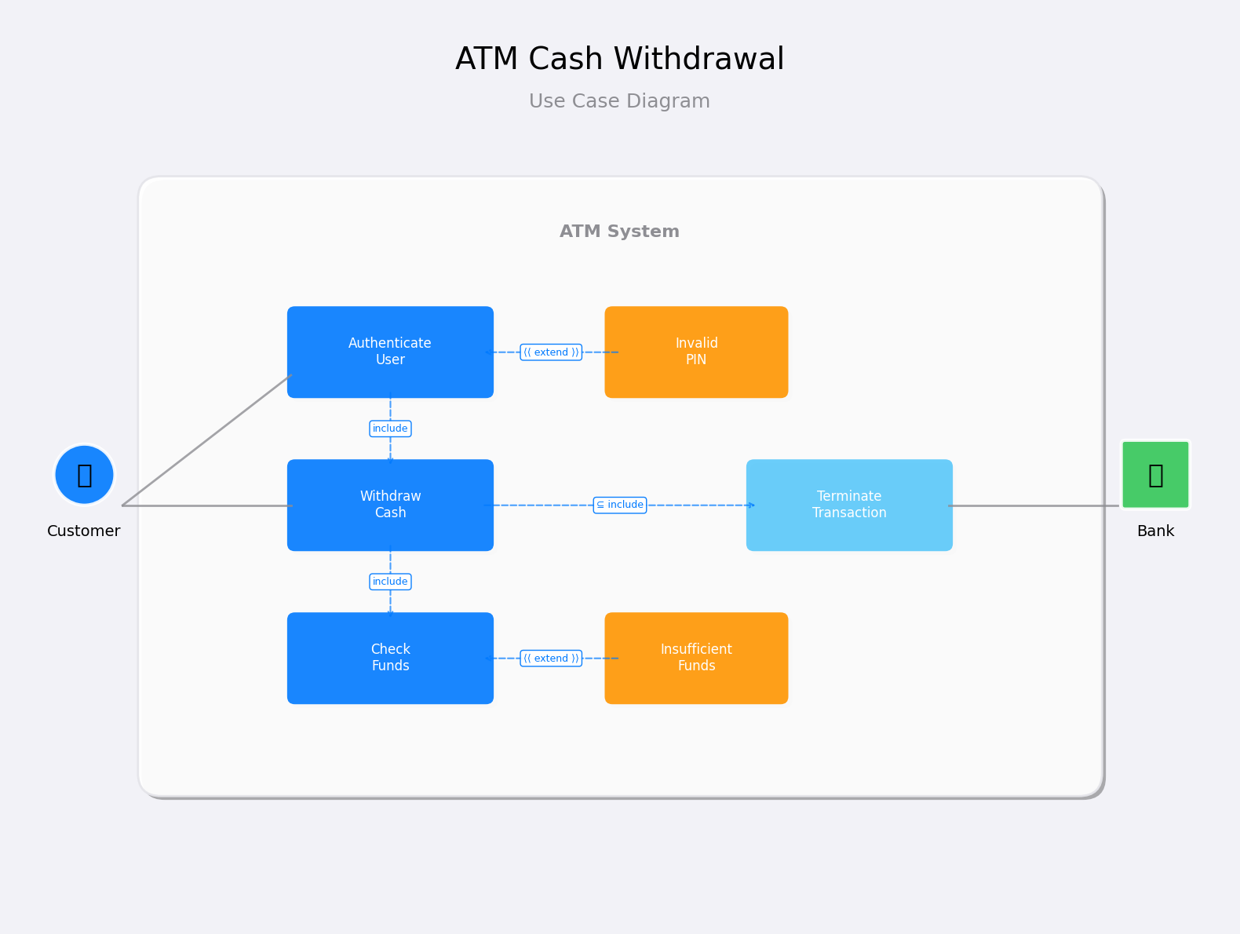

### UML Activity Diagrams

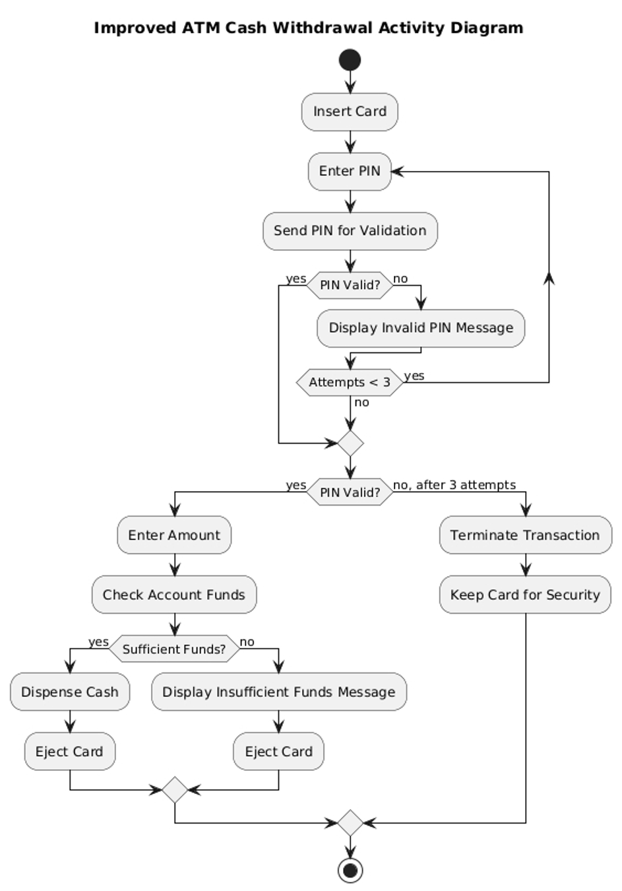

### UML Sequence Diagram

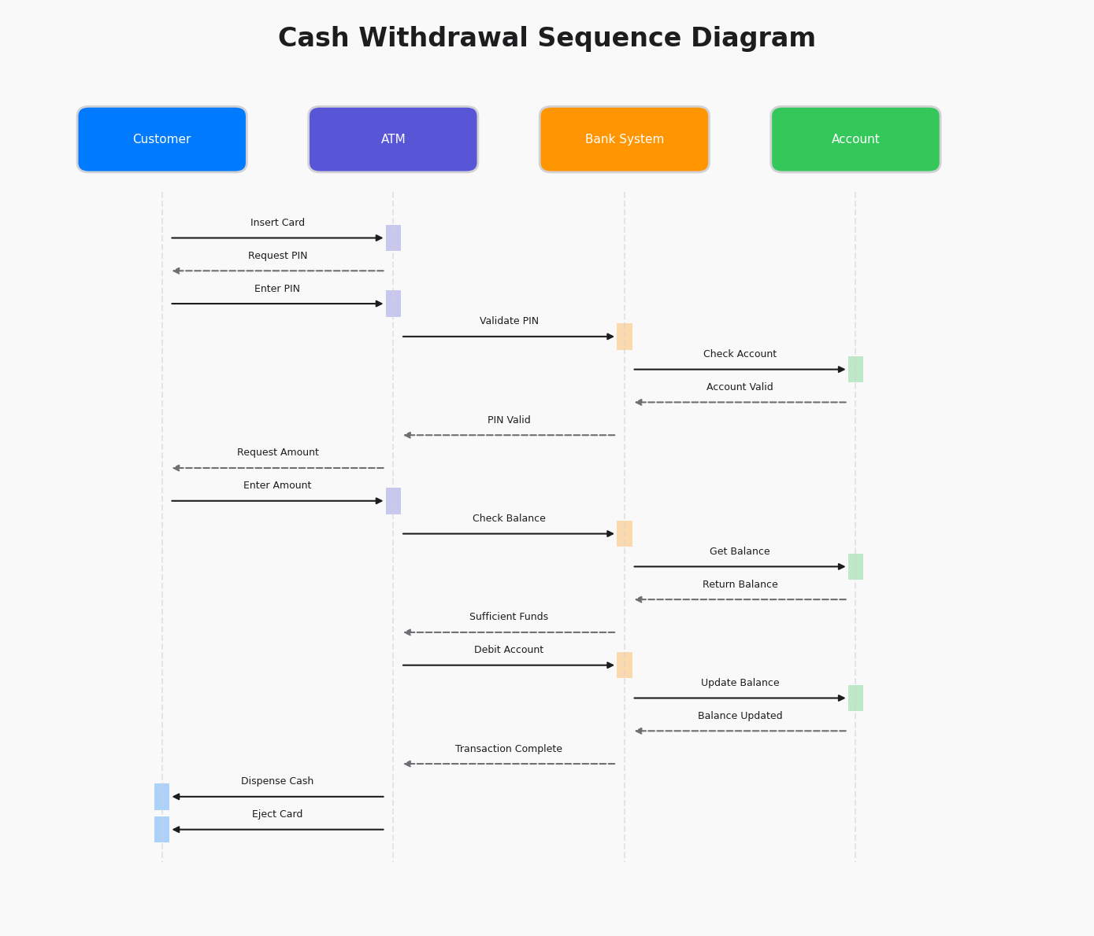

### UML Class Diagram

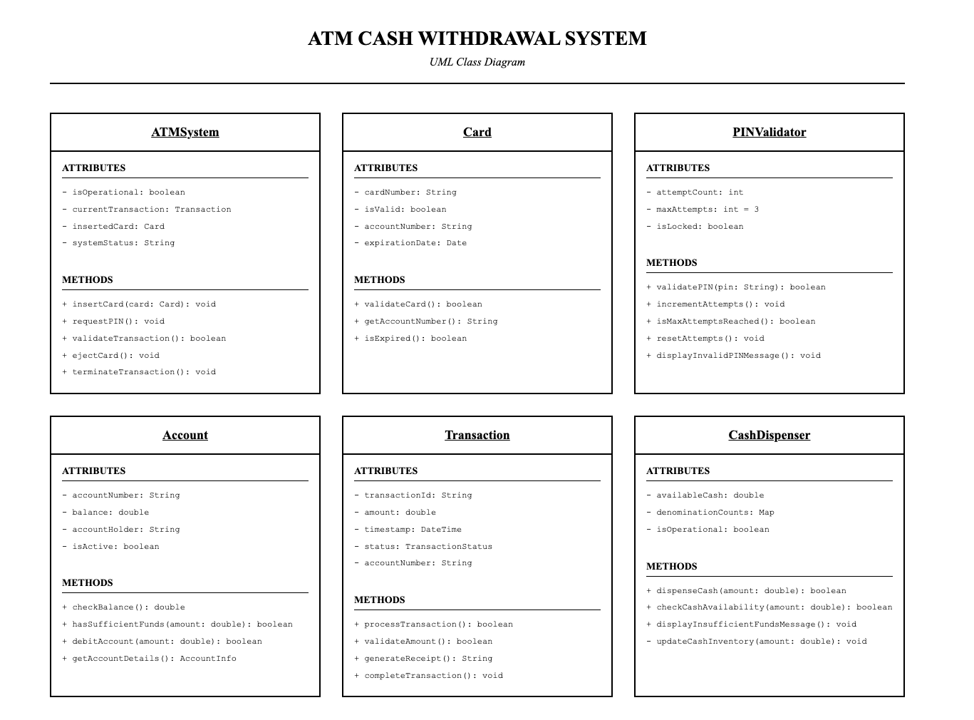

## Technical Requirements

To make the ATM cash-withdrawal system run, we basically need an ATM unit with a chip-card reader, keypad, secure cash dispenser, and internet-ready controller running a locked-down OS (Windows IoT or Linux), plus bank-side servers with a relational database, encrypted VPN/TLS links, and dev tools like Visual Studio with UML add-ons, all backed by steady power and redundant network lines so transactions keep rolling even if something hiccups.